**Health Final Study Guide**

**7 Dimensions of Health**

|  |  |  |
| --- | --- | --- |
| Category | Description | Example |
| Physical | Healthy body functions | 8-10 hrs. sleep |
| Emotional | Ability to manage emotions, and deal with life | Sense of belonging |
| Social | Maintaining healthy relationships | Communicating and listening to others |
| Spiritual | Sense of meaning and purpose in life | Not necessarily religious groups |
| Occupational | Having a job (could be a club or sport) | Participating in School sports |
| Environmental | Living in a healthy beneficial environment | Not living next door to a nuclear power plant |
| Intellectual/Mental | Ability to accept yourself and deal with life | No sense of depression |

**Health Continuum**

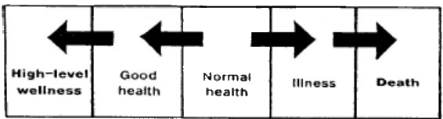

**7 Different Lifestyle factors**

1. Getting 8 Hours of sleep a night
2. Starting each day with a healthy breakfast
3. Eating a variety of nutritious foods each day
4. Being physically active 30-60 minutes each day
5. Maintaining a healthy weight
6. Abstaining from tobacco
7. Abstaining from alcohol and other drugs

**Healthy People 2010 Plan:**

To increase quality and length of life for Americans, and remove differences in health outcomes

**5 Key Points for Health Literate Decisions:**

1. Know where to find Health information
2. Decide if information is correct
3. Assess the risks and benefits of treatment
4. Figure out how much medicine to take
5. Understand test Results

**CDC:**

“Center for Disease Control”- Attempt to control and prevent disease in America

**5 Characteristics of Mental/Emotional Health:**

1. **Sense of Belonging**-Feeling close to family members, friends, teachers, and others
2. **Sense of Purpose**-Recognizing you have value
3. **Positive Outlook**-Seeing the Brightside of life
4. **Self-Sufficiency**-Having Confidence to make decisions
5. **Healthy Self-Esteem**-Ability to accept and recover from difficulties and failures

**Maslow’s Hierarchy of Needs:**

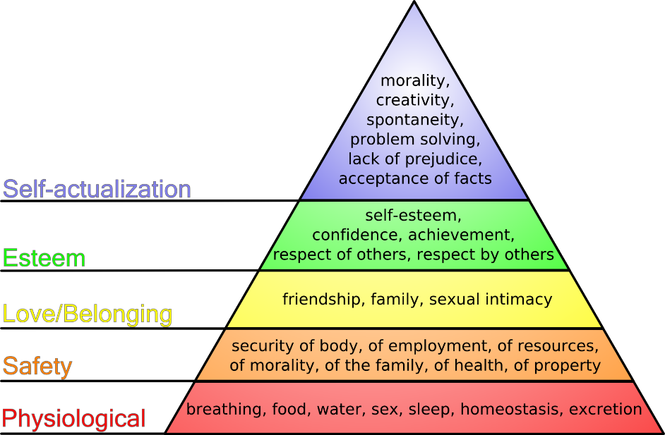

**Defense Mechanisms:**

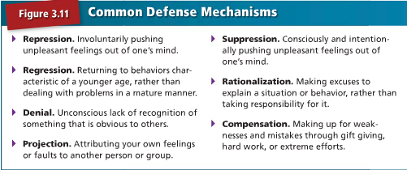

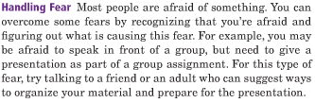**3 Most Common Emotions:**

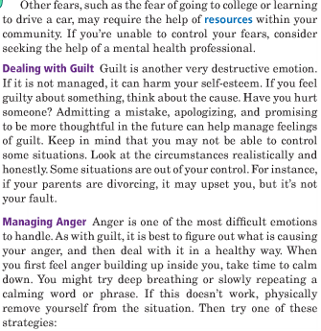

**4 Traits of A healthy Relationship:**

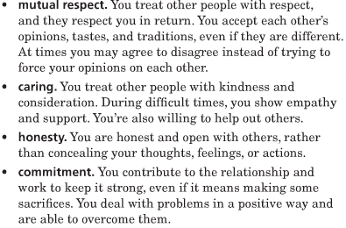

**3 C’s For Building Relationships:**

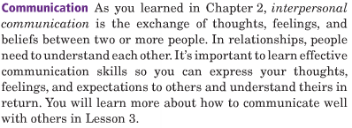

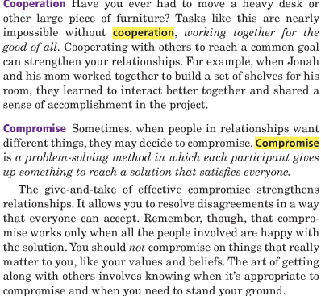

**Hazing:**

Making others perform a task to join a group. EX: Yelling, Screaming, Swearing

**Abuse:**

Physical, Mental, Emotional, or Sexual Mistreatment of one person by another. (Spousal Abuse, Child Abuse, Elder Abuse)

**STD’s**:

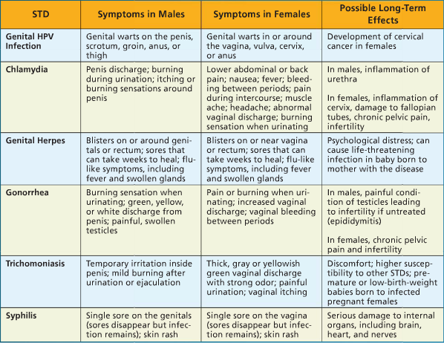

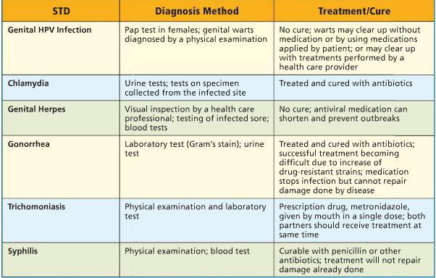

**My Food Pyramid:**

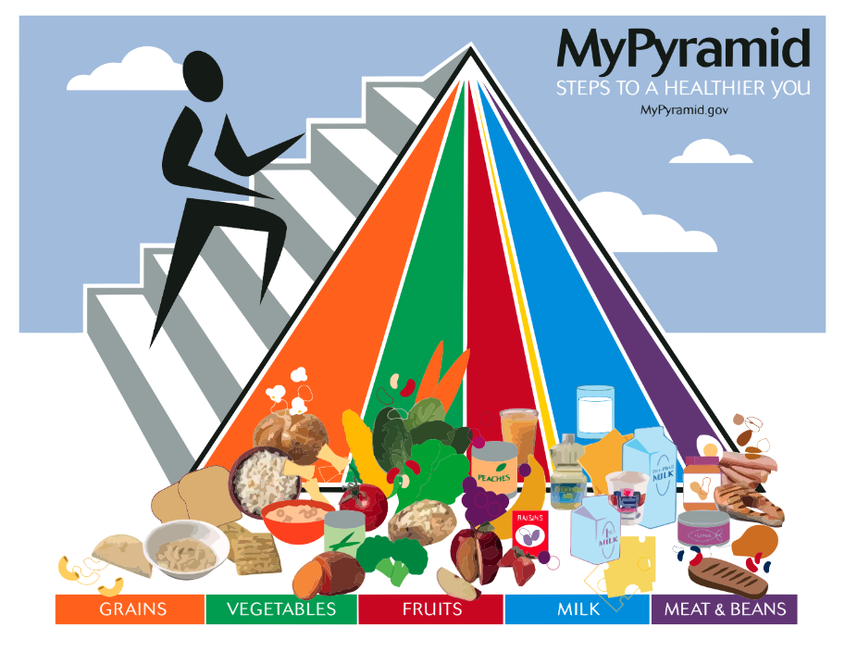

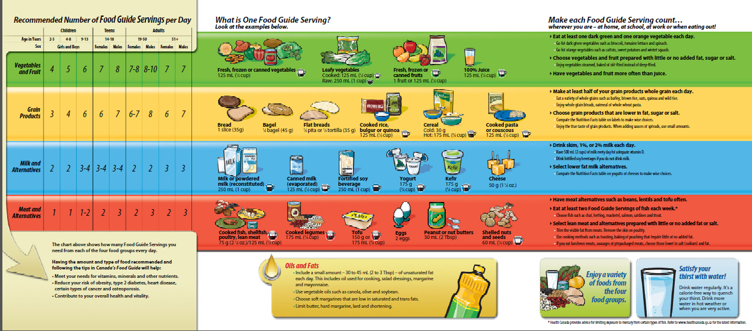

**Nutrients:**

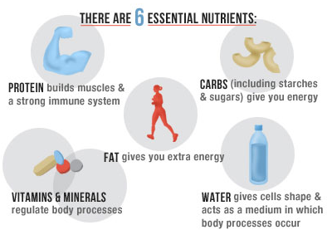

*Calories Found In Fat, Protein, and Carbs.  
**Simple Carb-Carb easily broken down  
***Main Fuel-Carbs  
****Complex Carb-Carb that takes time to break down

**2 Types of Proteins:**

1. Complete
   1. Contains all proteins not made by humans
      1. EX: Meats, animal products
2. Incomplete
   1. Contains Some proteins not made by humans
      1. EX: Peanuts, bread, etc.

**3 Types of Fats:**

1. Saturated
2. Unsaturated
3. Trans

**Calories per Gram:**

1. Fat-9/gram
2. Proteins-4/gram
3. Carbs-4/gram

**Vitamins:**

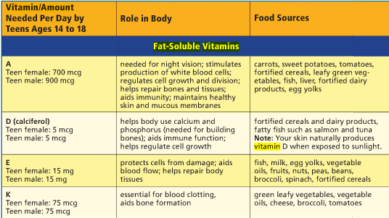  
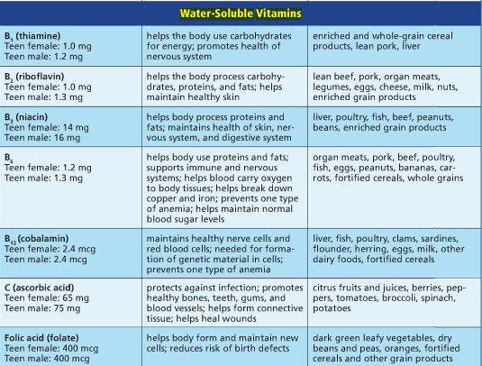

**Eating Disorders:**

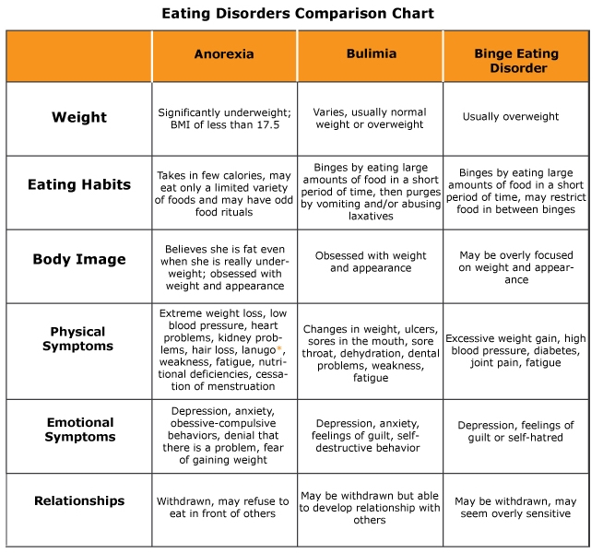

*Eating Disorders-Mental Issue

**Fad Diet:**  
A diet that has high claims and is only popular for a short amount of time. EX:

1. Miracle Foods
2. Magic Combos
3. Liquid Diets
4. Diet Pills
5. Fasting

**4 Steps for Food Preparation:**

1. Clean
2. Separate
3. Cook
4. Chill

Herbal Supplements-Dietary supplements containing plant extracts

**3 Main Chemicals in Tobacco:**

1. Nicotine
2. Tar
3. Carbon Monoxide

**Smoking while pregnant-** Smoking during pregnancy affects you and your baby's health before, during, and after your baby is born. The nicotine (the addictive substance in cigarettes), carbon monoxide, and *numerous* other poisons you inhale from a cigarette are carried through your bloodstream and go directly to your baby.

**ETS-**Air contaminated by tobacco smoke

**Quitting Tobacco**

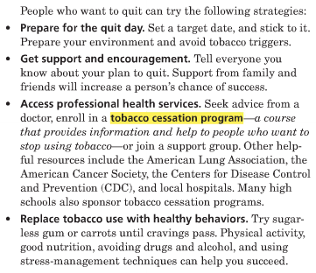

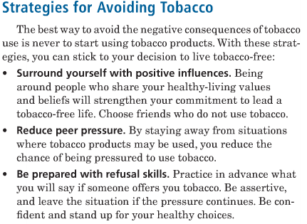

Ethyl Alcohol-Alcohol in drinks

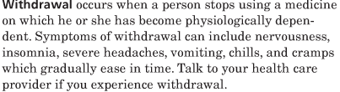

In IL you must be 21 to drink and you can drive with a BAC under .08

FAS-Fetal Alcohol Syndrome-Birth defects caused by alcohol

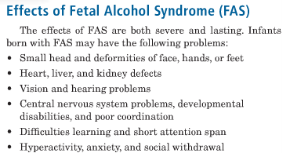

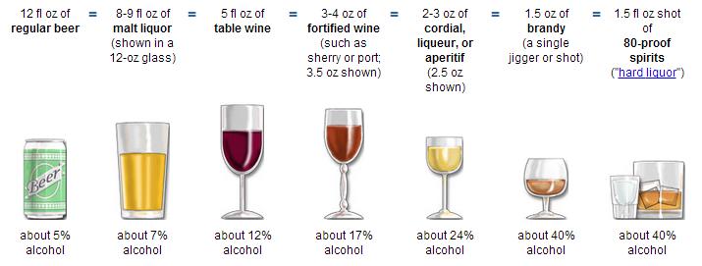

|  |  |  |
| --- | --- | --- |
| Drug Category | Effect on body | 3 Drugs |
| Steroids | Increases Muscle Mass | Depo-Testosterone  Oxandrin  Durabolin |
| Marijuana | Effects Vary | Hashish  Cannabis  Marijuana |
| Inhalants | Gives “high” Feeling | Felt Tip Pens  Paint Thinner  Nail Polish Remover |
| Club Drugs | Combo of hallucinogens and stimulants | Ecstasy  GHB  Rohypnol |
| Stimulants | Speed up Central Nervous System | Cocaine  Meth  Amphetamine |
| Depressants | Slows Central Nervous System | Barbiturates  Alcohol  Benzodiazepines |
| Hallucinogens | Visual distortions | LSD  Peyote  PCP |

**Look-A-Like Drug:** Drug made to look like a popular drug for sale

**5 Different Ways a Drug can enter the body:**

1. Snort
2. Pill
3. Inject
4. Inhale
5. Ingest

**Designer Drug-** drug designed for a specific effect

**Gateway Drug-** drug that usually leads to use of stronger drugs